Science Quest 2024
PROJECT PROPOSAL FORM

Name of School:

Category:

Project Title:

(Note - Your project proposal should include the following: Introduction, aims/ objectives, proposed methods/ experiments/ materials to be used, expected outcome).

1.0 Introduction (background, rationale of project)

(2 Marks)

2.0 Aims & Objectives

(3 Marks)

3.0 Proposed methods/ experiments/ materials

(You may attach one additional page for diagrams if necessary)

(10 Marks)

4.0 Expected Outcomes (Impact on school/locality)

(5 Marks)

Additional marks: Relevance to title, originality, creativity & Innovation
(To be assessed by the Jury Panel) (5 Marks)

Total marks: 25

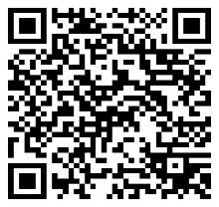

Scan the QR Code to register and upload your project proposal form.
Deadline: 16 February 2024
Contact us on education@rgsctf.org

